**Facilities:**

With the expansion in academic program, computer laboratories in the department have risen to nine spreads over two buildings. The laboratories are equipped with 200+ computers fully network with state of the art server.



Computer to student 1:1. The department is proud of it’s piracy policy. Oracle has contributed software worth more 40 million.

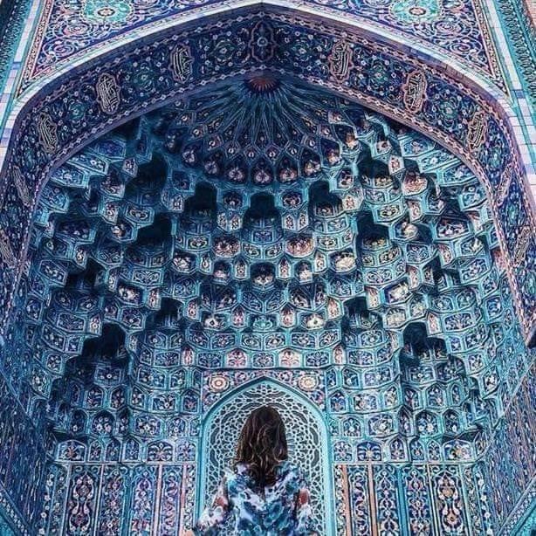

Here now we also offer double degree program. Three students each from the

**Faculty:**



* Prof Dr. Khaldoon Khursheed
* Prof. Dr. Shahzad (Chairman)
* Professor Dr. Amaj Farooq.

**Contact details:**

For queries contact us on your official website

[www.uet.edu.pk](http://www.uet.edu.pk)

**call on:**

031962996299

Prepared by: Hira Iqbal

Roll no: 2023 CS-86

To the students of the department emphasizing entrepreneurship and ethical standards while encountering them to remain abreast with latest developments in computing tool and processes and uses their skills to identify and find skills to society’s problem;

**University of Engineering and Technology** A brief discussion of computer science and engineering department is here.

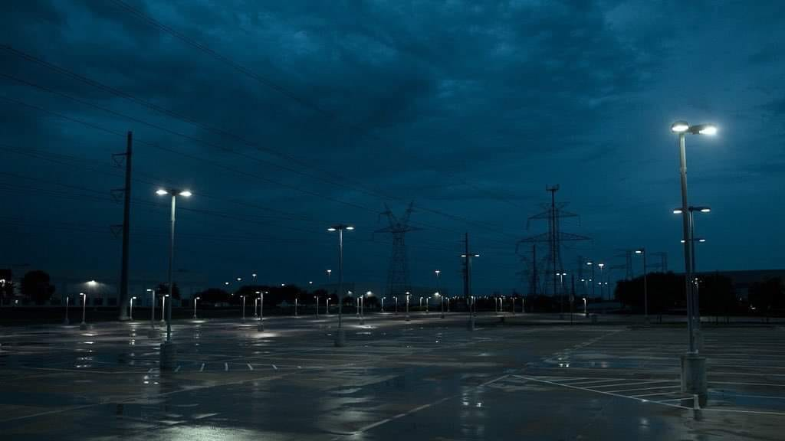

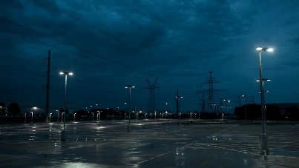

**Introduction:**

The department of computer science and engineering was originally established as Department of computer science in 1991. Its history dates back to the year 1968.

Graduating class of computer science and computer engineering may opt for a second degree in computer engineering and science as may be the case the subject to fulfillment of prescribe conditions, from fall semester 2011.

**Research:**

and related areas. Databases, semantic web and related areas.



And to use department resources and computing expertise to help industry, government and community in solving their problems.

|  |
| --- |
| Computer scientist jobs should be way more interesting than even going to wall street or being a lawyer or, I can argue, than anything but perhaps biology, and there it’s just a tie.  “Bill gates” |

**Degree and Double degree**

**Program**:

Here we offer degree program in terms of Bs hons which was introduced by the department in 1999. The degree of this program is affiliated by PEC (Pakistan Engineering Council)